**Ashley River Lumber Slab Inventory Installation and Operators Manual**

Slab Tracker.exe v1.0

SlabsDB.accdb v1.53

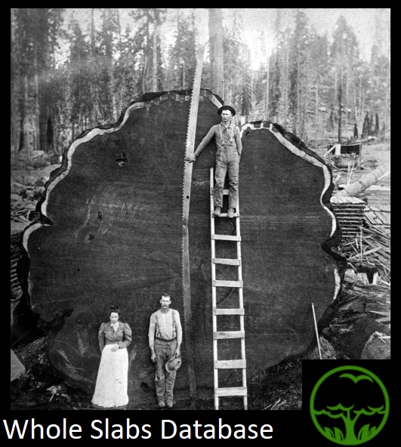

Designed and Created by Benjamin Lucas

Table of Contents

* Installation….………………………………………………………..…………………………………………………….2-4
* What’s In Your Folder?.………………………………………….…………………………………..………………….5
* Launch Screen……………………………………………………..…………………………………………………………6
* Main Window/ In-Stock Tab………………………….…………………………………………….………….....7-8
* Sold Tab…………………….….……………………………………………………………………………………………….9
* Species Tab……….………….………………………………………………………….…………………………..…10-11
* Reports Tab…….……………….……………………………………………………….………………………………….11
* Utilities………..…………………….…………………………………………………….………………………………….12

**Installation**

Installation is quick and easy! Once you have the ‘SlabTracker v1.0.zip’ folder, simply double click the file:

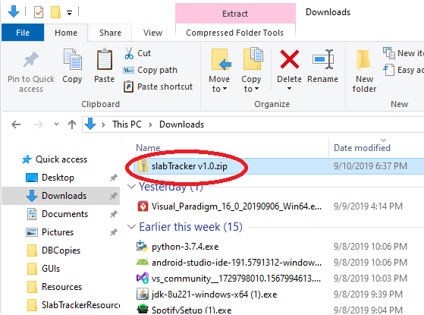

Then click extract all:

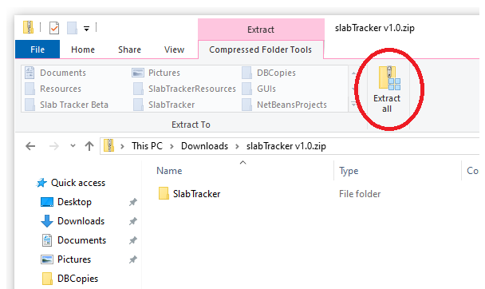

Next you will see a window asking you to select the folder you want to unzip the file to. You may be ok with the default or you can browse to a preferred folder, then click extract:

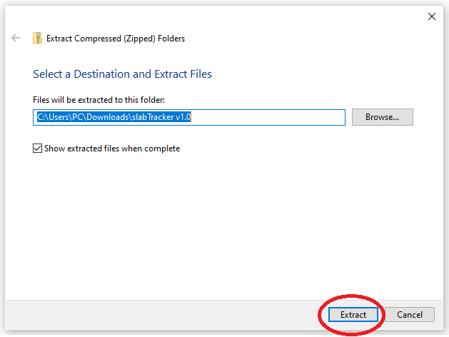

Next, to get started all you need to do is click on the SlabTracker.exe file and the program will start!

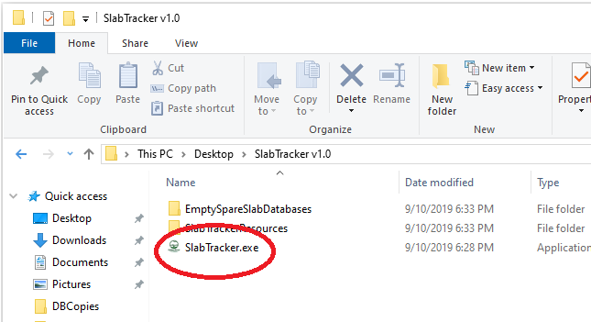

**What’s In Your Folders?**

When you opened the folder with the SlabTracker.exe file you may have noticed a few other folders. In the SlabTrackerResources folder you will find some .txt or text files. The dbConfig.txt file is where the program stores the last known location of the last database it connected to. If this file is missing or not in the proper place the program will still run, but it will tell you that it can’t find that file. It will then create another one. The other four .txt files are the files that are generated when you press the print buttons in the table tabs or reports tab. If these files are missing or the folder that contains them is missing, the program will recreate them in the SlabTrackerResource folder. If the SlabTrackerResource folder is accidentally moved or deleted, the program will also recreate that when it is run. Lastly, you will see the slabDB-Emtpy.accdb. This is your fresh new database. The program will know where this is located the first time you open it unless you change the file name. **WARNING**: **DO NOT DELETE EVER THIS FILE**. This is how the program stores the inventory! **IF YOU LOSE THIS, YOU LOSE YOUR ENTIRE INVENTORY**! You will have to enter every slab in again manually. I recommend that once a week you make a copy and save it somewhere as a backup. It is very important! It’s so important that I have given you spares. That would be what is in the EmptySpareSlabDatabases folder. Just more empty databases in case the original is deleted somehow. You can rename these databases to whatever you want as long as you have .accdb at the end of the filename. As long as you have the **database file** and the **SlabTracker.exe** file your program will run!

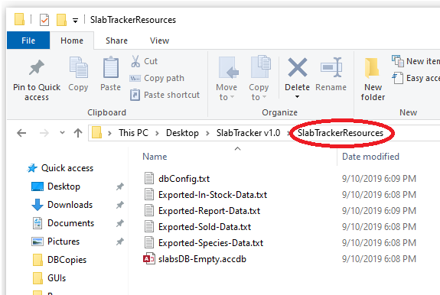

**Launch Screen**

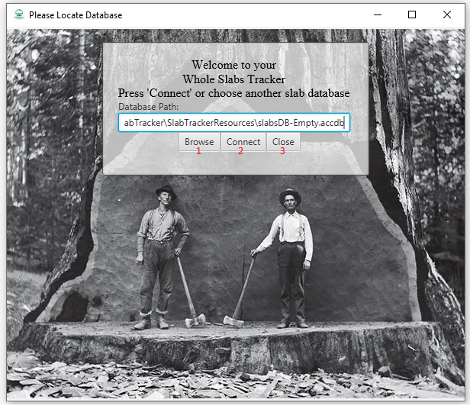

1. The **Browse** button allows you to browse through folders and locate your database. The last database path you connected to will be saved and brought up here next time. This browse file window will only let you select .accdb files so that the program won’t explode!
2. The **Connect** button will attempt to connect to the database that is listed in the **Database Path** box. If the path is incorrect then the program will tell you that the database no longer resides there. You can then either manually enter a valid database path or browse for one with the **Browse** button.
3. The **Close** button closes the program.

**Main Window/In-Stock Tab**

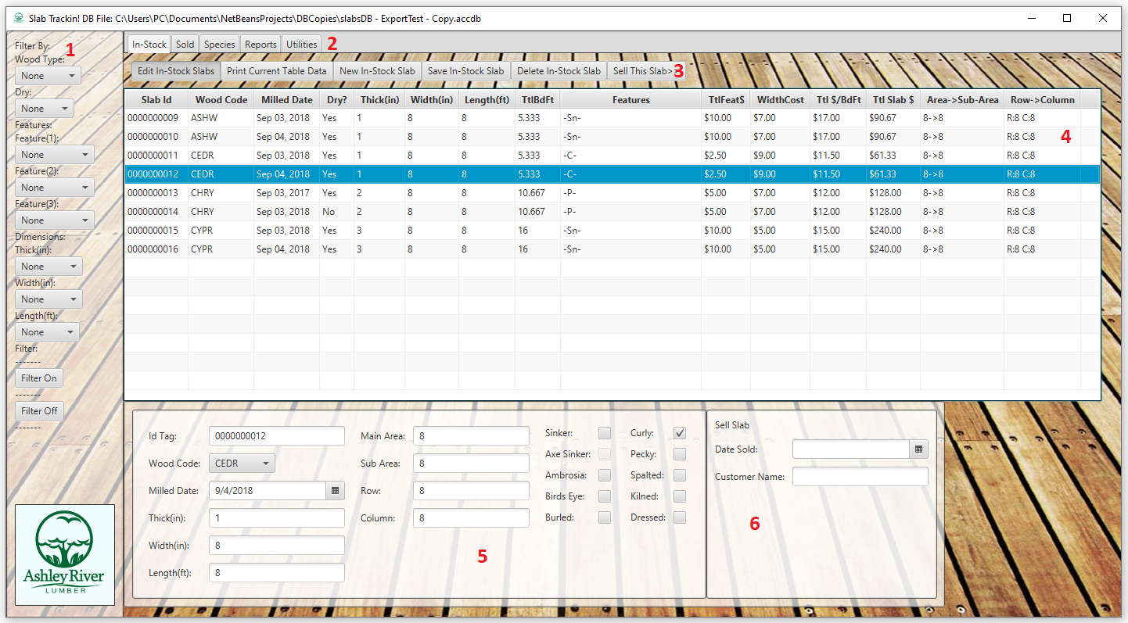

1. This is the filter selector section for the In-Stock and Sold Slabs Tabs. First, you choose which filters you want to apply. Then you press the **Filter On** button and both the In-Stock and Sold Slabs tabs are filtered simultaneously. When you want to remove the list filter you simply press the **Filter Off** button.
2. This is The Tab Selector sections. Select the tab of your choice by pressing it.
3. This is the In-Stock slab button section:
   1. **Edit In-Stock Slabs** – Deselecting this button will make all the other buttons except the **Print Current Table Data** button disappear. It will also disable all input fields at the bottom. Selecting the button reverses all of this.
   2. **Print Current Table Data** –opens a Notepad text file containing everything that is presently in the In-Stock table. You can then print the contents of the table from the text file.
   3. **New In-Stock Slab** – this clears the input fields and allows you to create a new slab.
   4. **Save In-Stock Slab** – this save the data currently entered in the input fields in the bottom section. If the fields are filled out incorrectly or a needed field is missing the program will let you know what is needed.
   5. **Delete In-Stock Slab** – this will ask for a password, then if entered correctly the currently selected slab will be deleted. If no slab is selected in the table, the button will not be there.
   6. **Sell This Slab** – if the **Date Sold** and **Customer Name** input boxes are filled out, then this will move the selected slab to the **Sold Slab** table. If no slab is selected in the table, the button will not be there.
4. This table shows all the In-Stock slabs in the database. If the filter is on it will only show the slabs that match the filter selections.
5. This is the new slab input fields. The **Edit In-Stock Slabs** toggle button must be pressed to edit these fields. To save the input data in these fields you must press the **Save In-Stock Slab** button. If the input data is incorrect, the program will tell you what needs to be corrected.
6. This is the Sell Slab input fields. The program will not let you sell a slab if these fields are not filled out correctly.

**In-Stock Tab**

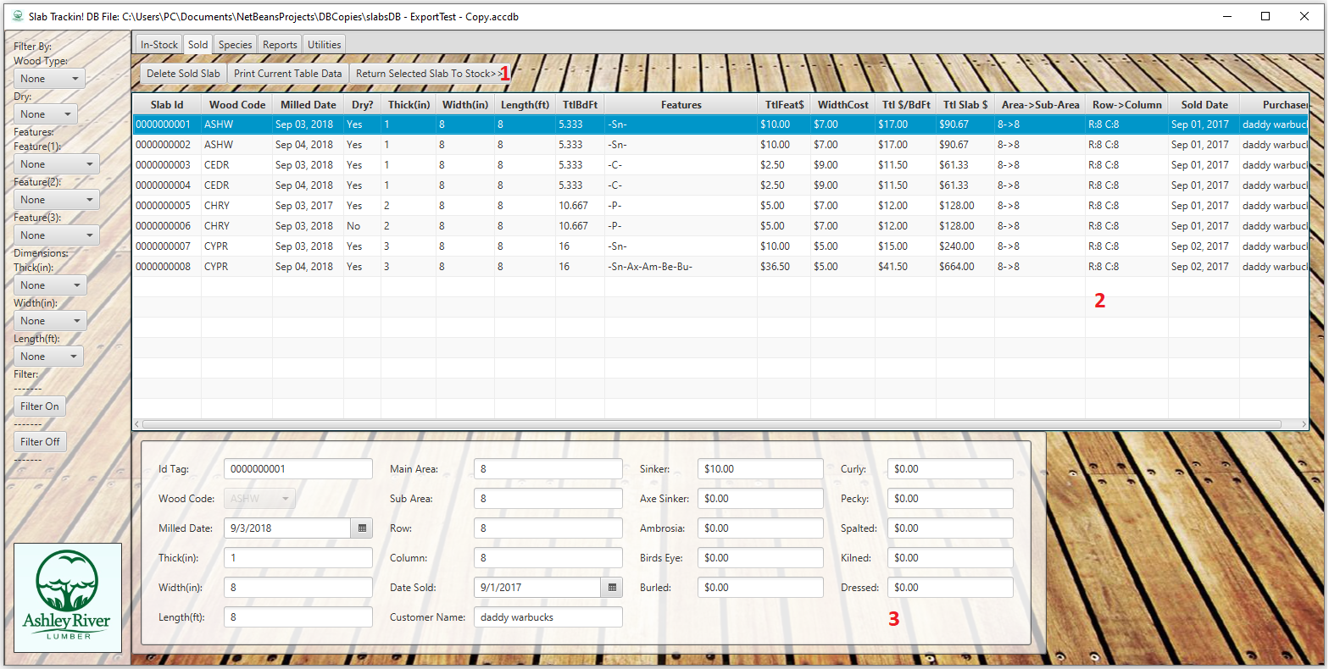

This is the Sold Tab. This is very similar to the In-Stock tab but it has less functionality. You cannot edit slabs or add new slabs here. This is because of the need to preserve pricing and sales data. When a slab is moved from In-Stock to Sold then the pricing data is saved at the current prices of the time of the sale. This makes sales data accurate after Species prices change.

1. This is the Sold Slab buttons:
   1. **Delete Sold Slab** – this button will delete the presently selected slab after the user inputs the password.
   2. **Print Current Table Data** – this will open a text file in notepad containing the data that is currently present in the table so the user can print it.
   3. **Return Selected Slab To Stock** – returns the currently selected slab back to the In-Stock table after the use inputs the password.
2. This area shows all the slabs in the Sold Slabs table. This table is filtered using the filter options on the left of the window.
3. This is the data for the currently selected Sold slab. It cannot be edited. It allows the user to see pricing for each feature on the selected slab as well as the other slab variable.

**Species Tab**

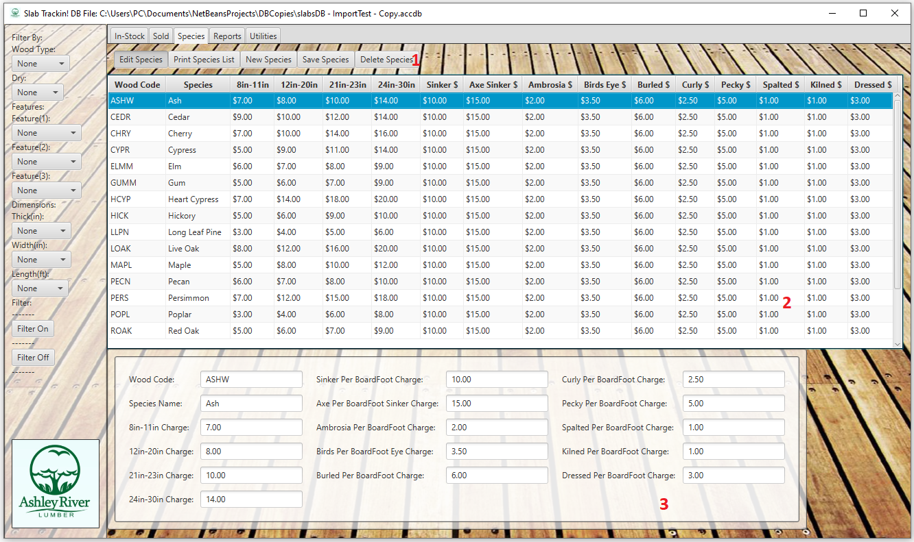

This is the Species Tab. The data in this tab is what determines pricing for different the different slab tree species. Here you set width pricing as well as feature pricing. When you add a new species the Wood Code will appear in the Wood Code selection box of the new In-Stock Slab that is input in the In-Stock tab.

1. This is the Species button section:
   1. **Edit Species** – Deselecting this button will make all the other buttons except the **Print Species List** button disappear. It will also disable all input fields at the bottom. Selecting the button reverses all of this.
   2. **Print Species List** –opens a Notepad text file containing everything that is presently in the Species table. You can then print the contents of the table from the text file.
   3. **New Species** – this clears the input fields and allows you to create a new species.
   4. **Save Species** – this save the data currently entered in the input fields in the bottom section. If the fields are filled out incorrectly or a needed field is missing the program will let you know what is needed.
   5. **Delete Species** – this will ask for a password, then if entered correctly the currently selected slab will be deleted.
2. This table shows all the Species in the database.
3. This is the new species input fields. The **Edit Species** toggle button must be pressed to edit these fields. To save the input data in these fields you must press the **Save Species** button. If the input data is incorrect, the program will tell you what needs to be corrected.

**Reports Tab**

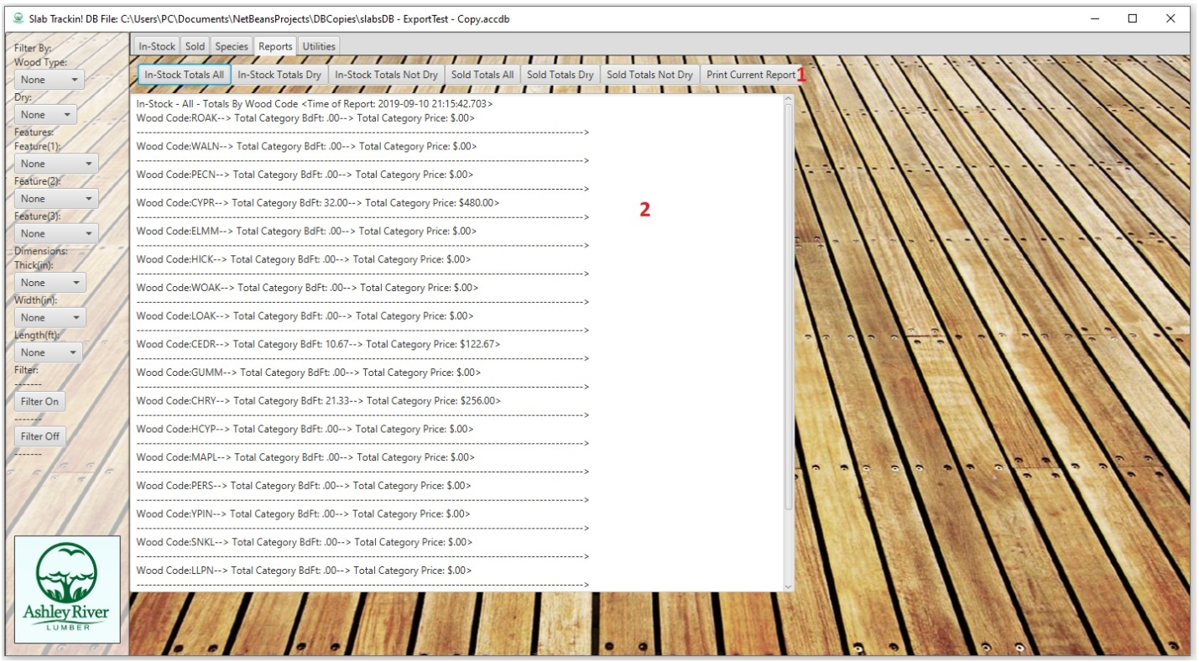

This tab gives a summation of board feet and pricing per species and the total for everything in each table.

1. This is the button area. The reports are broken up into All/Dry/Not Dry for each table(In-Stock and Sold). There is also a print button that will allow the user to export the report data to Notepad so it can be printed.
2. This is the Report data area. This area will contain the data that corresponds with the last button that was pressed.

**Utilities Tab**

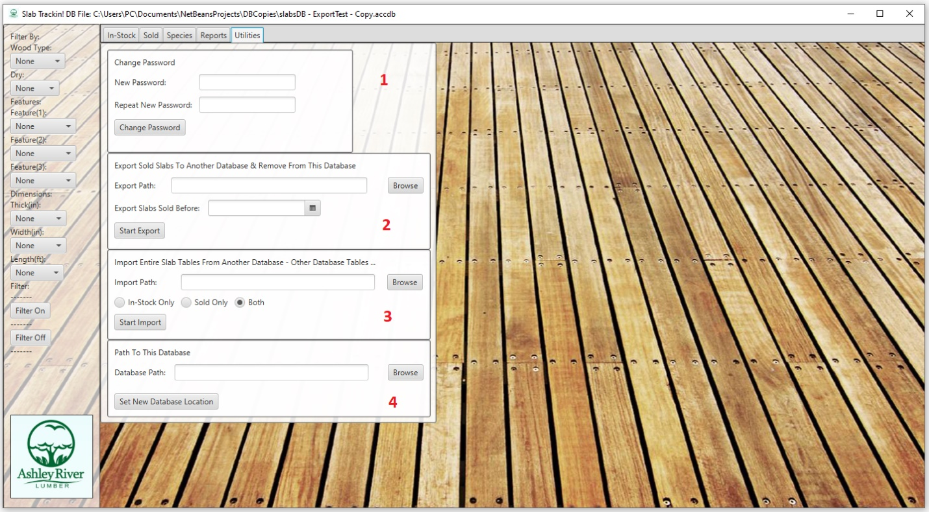

This is the Utilities tab. This tab allows the user to change the password, switch databases, import data from other databases and export data to other databases.

1. This is the change password area. The password is mainly meant to keep people from deleting the wrong data or messing up historical pricing in the Sold slabs table. You must enter two identical passwords for the password to be changed. If you leave both fields blank, then the password will be a blank string. This can make deleting large amounts of data easier but is not recommended as a regular state.
2. This is the export area. This will export data from the Sold Slabs table to another database with the same structure. This will allow for archiving old sales data. The date field in this area determines which slabs are moved. All slabs sold before the selected date will be moved to the other database.
3. This is the import area. This allows you to import Sold or In-Stock slabs from other databases with the same structure. The data in the other database is not deleted, however.
4. This set new database area. This allows you to switch the presently connected database without closing the program.